**Azure Kubernetes Service creation**

1. Go to create new resource and search for kubernetes services and then “create” it.

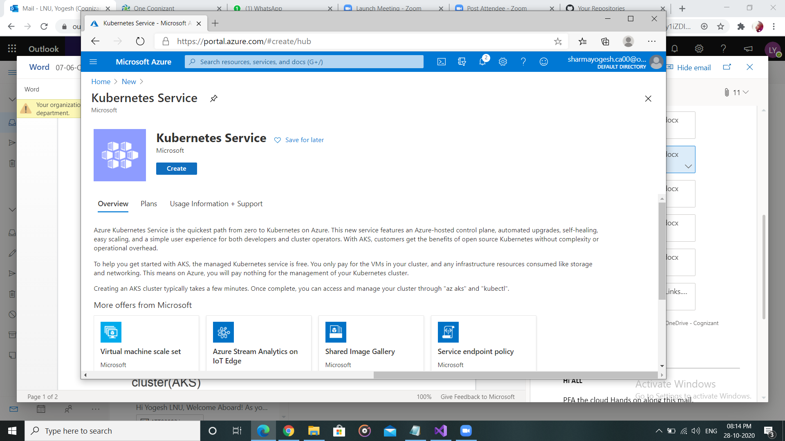

1. Provide the desired details and click “review+create”. Then “create”

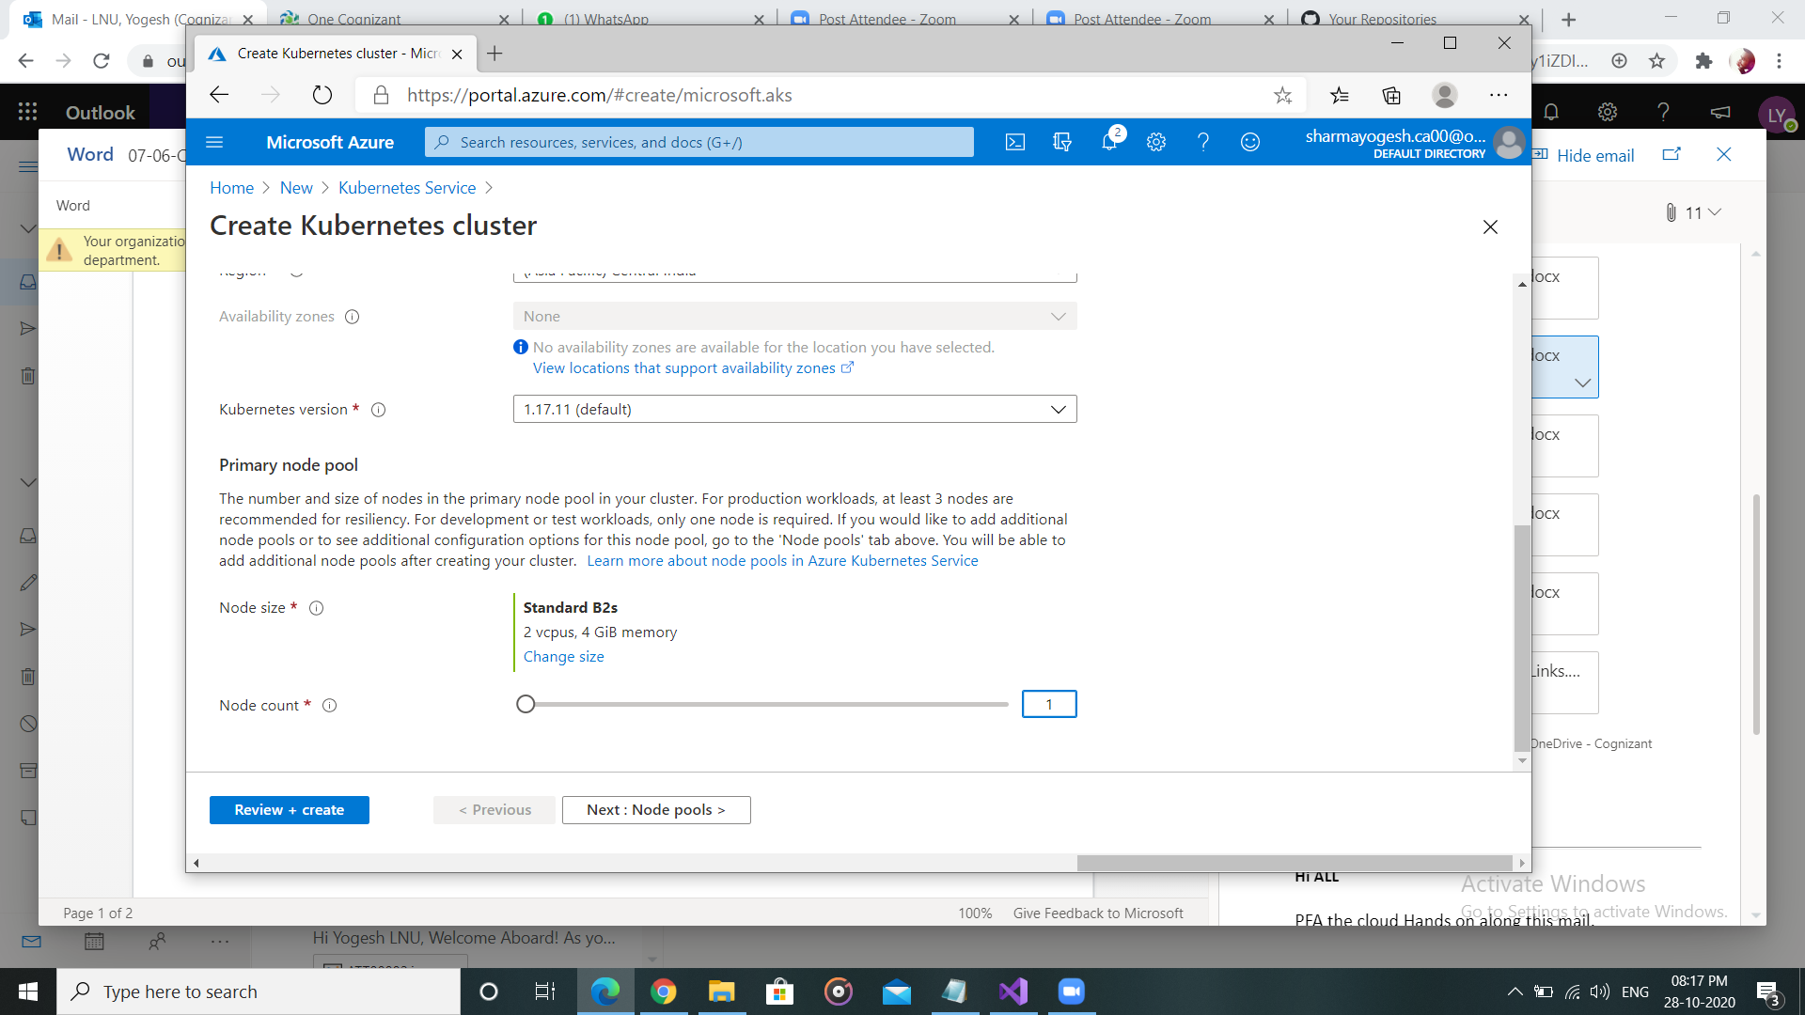

1. Wait for the deployment to get completed. Then “go to resource”

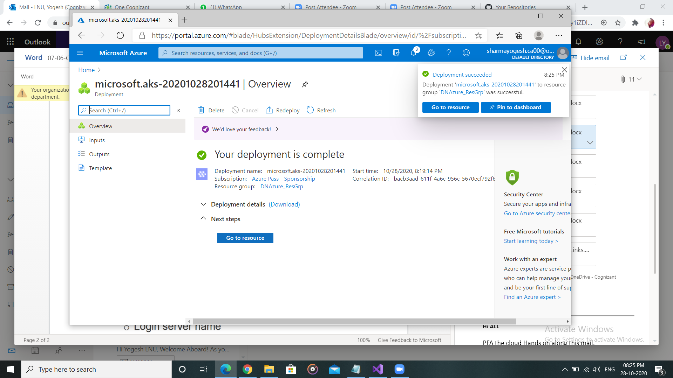

1. Check node pools and names to verify the details.

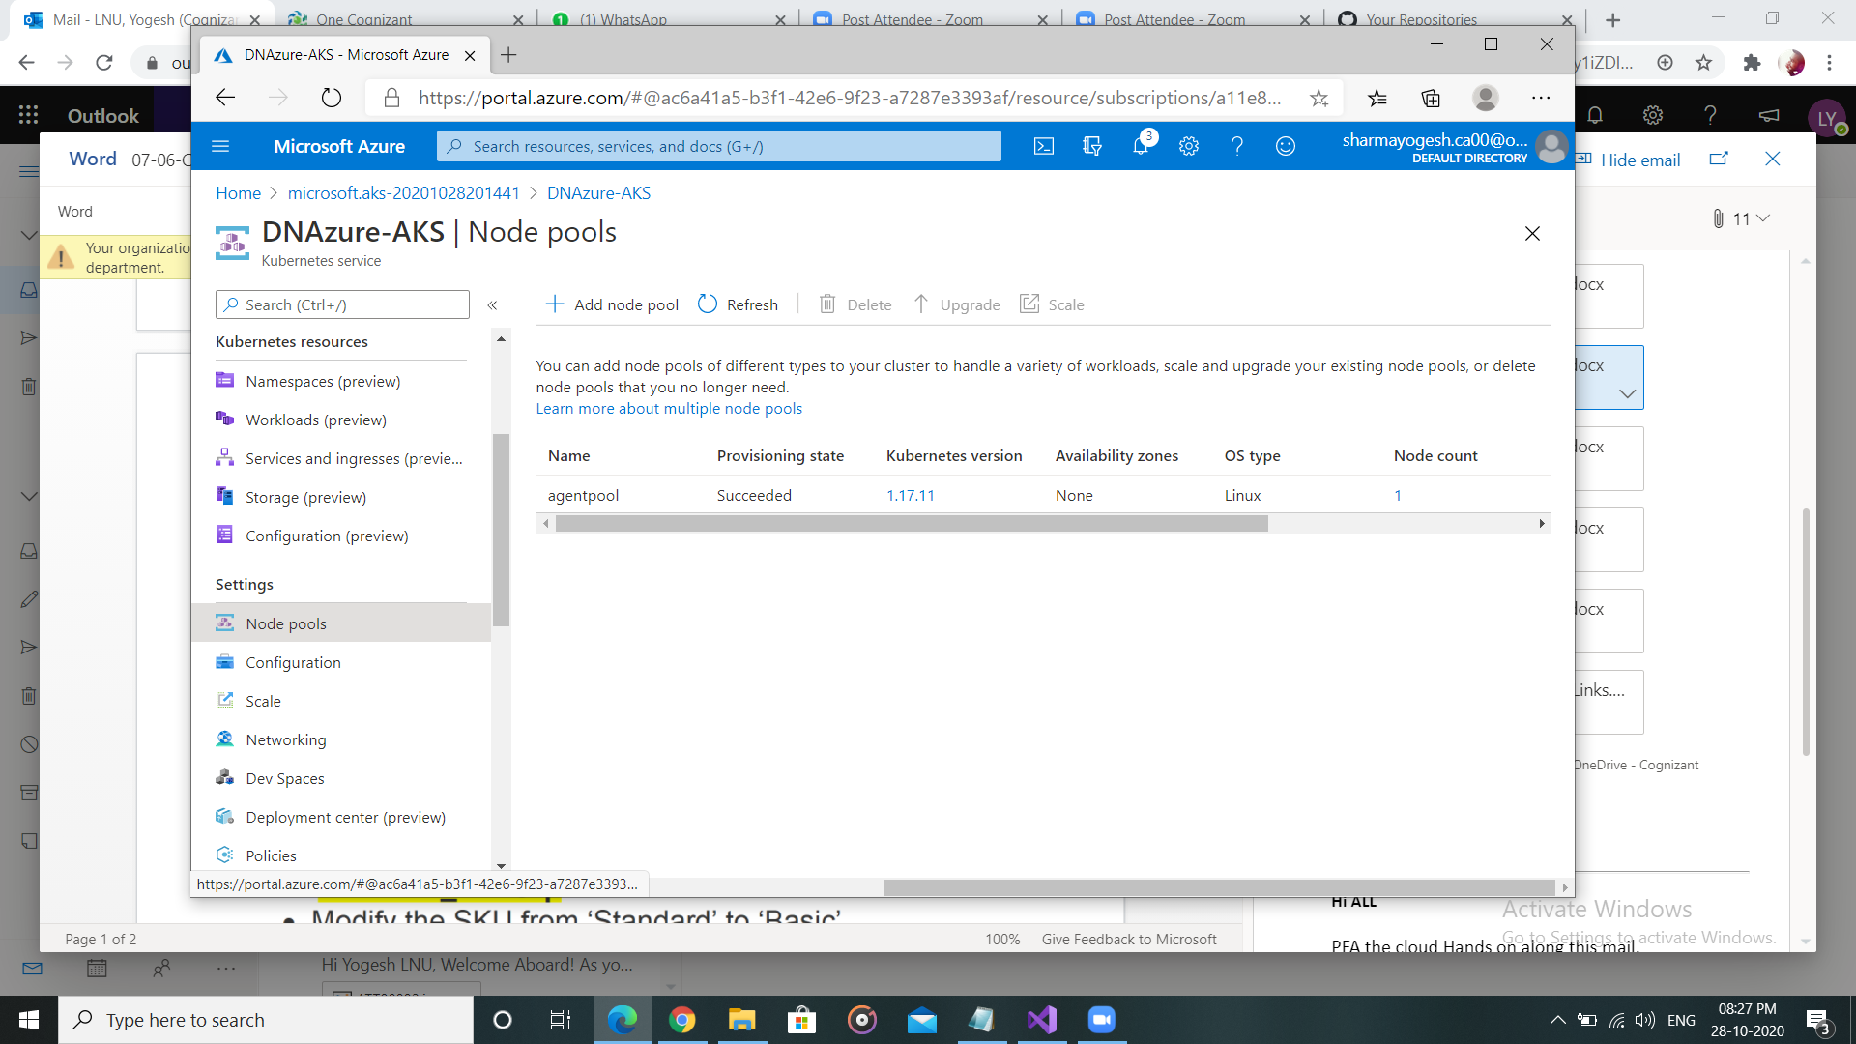

**Azure Container Registry creation**

1. Go to “new resource” and add “container Registry”. Fill the appropriate details and create it. Change sku to basic

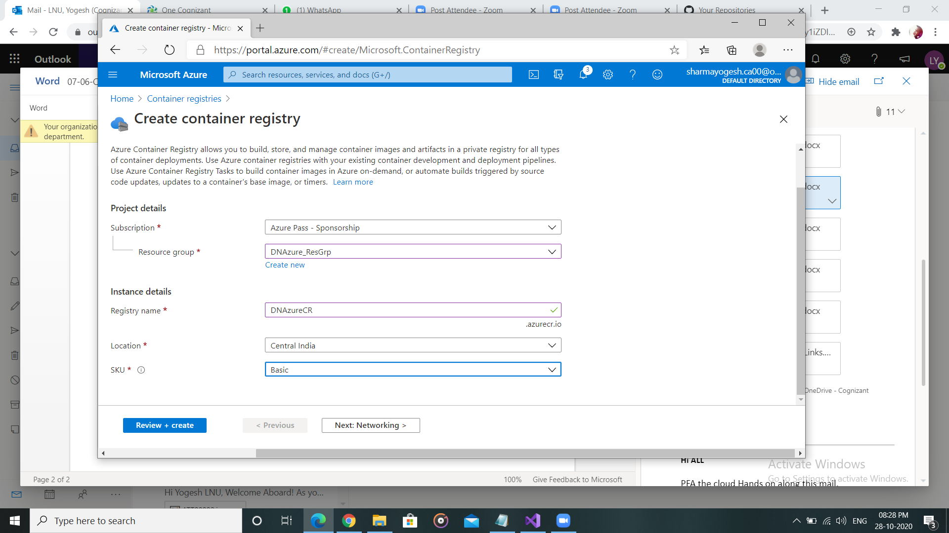

1. After deployment is complete, go to resource.

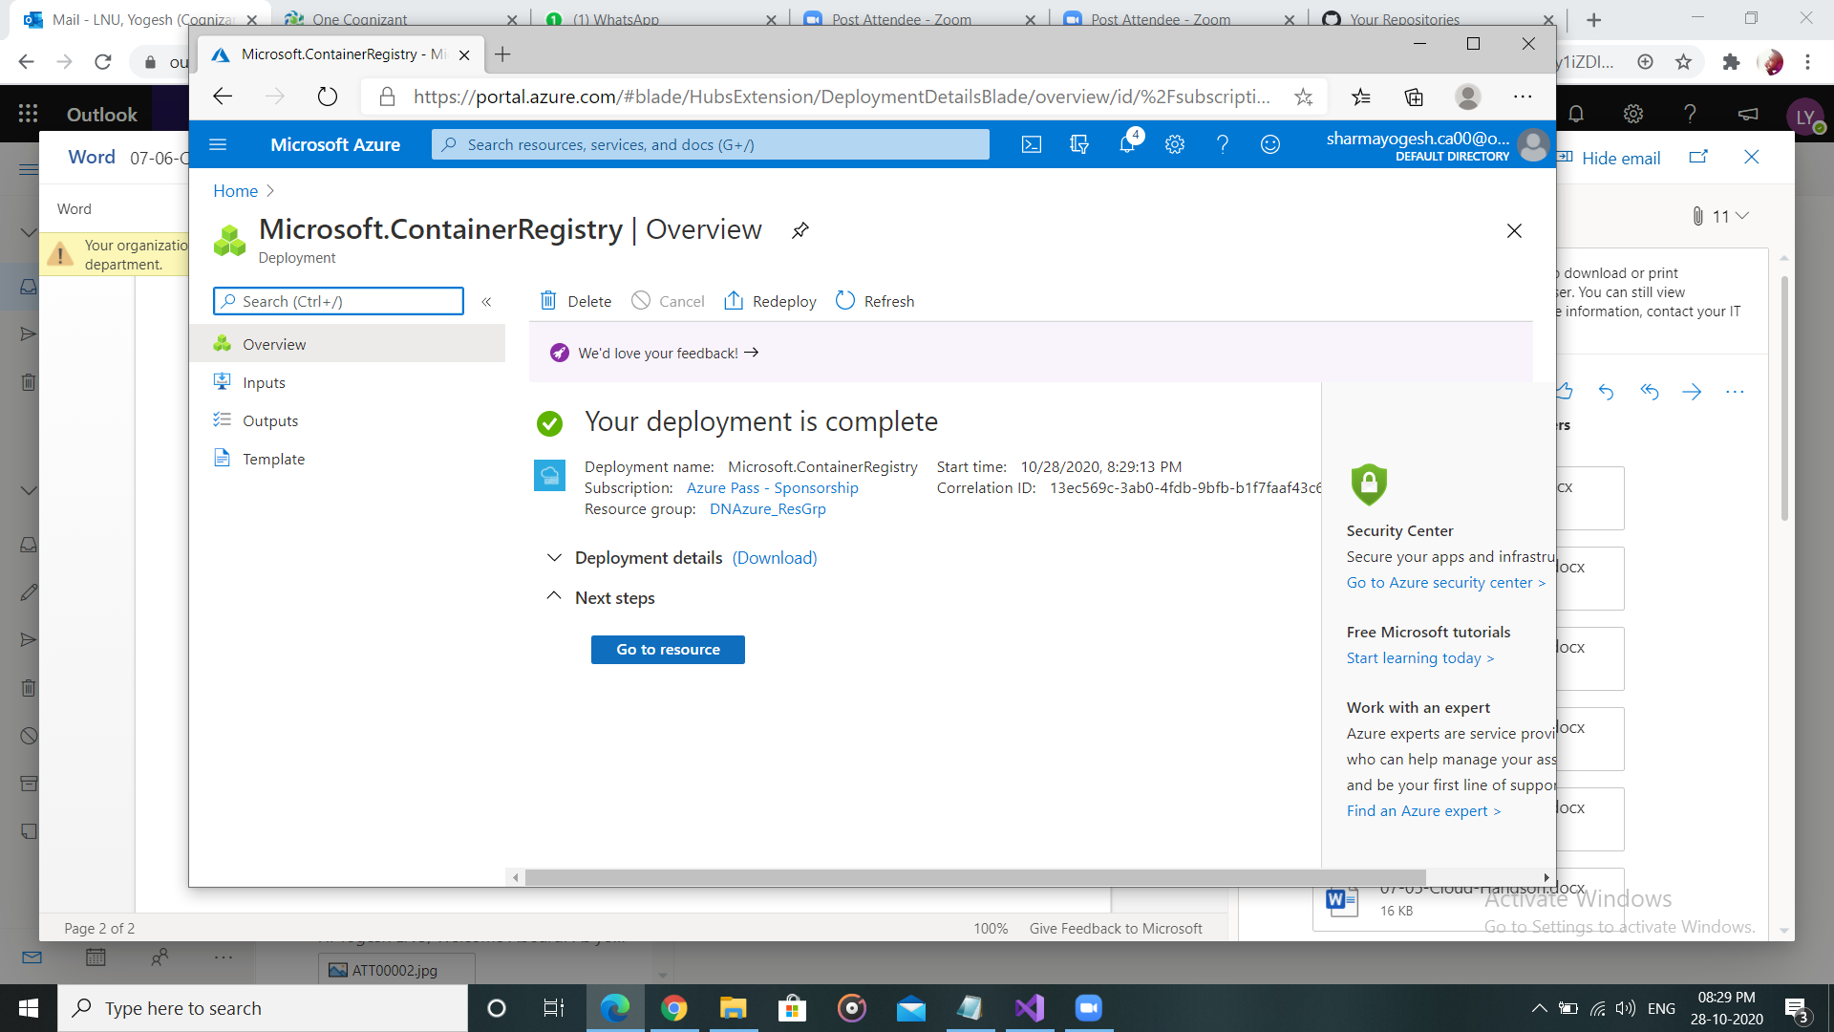

1. Check the details and verify the login server name.

